***Master’s in Computer Science Project Proposal***

Student: Scott Gale

Project Advisor: Professor Pierre-Emmanuel Gaillardon

**Title:** AirU – IOT Cloud Solution: Cyber-physical solution for monitoring air quality.

**Project dates:** 7 January 2019 – 01 December 2019

**Context / Background:** The Laboratory of Nano-Integrated Systems (LNIS) currently has a fully functional air quality sensor network deployed throughout the Salt Lake Valley. This system periodically samples data (1 sample per minute) and then sends the data to a server located at the University of Utah via MQTT and Telegraf. The data is visualized through a web browser. The web server is hosted by Google.

*Current System Model*

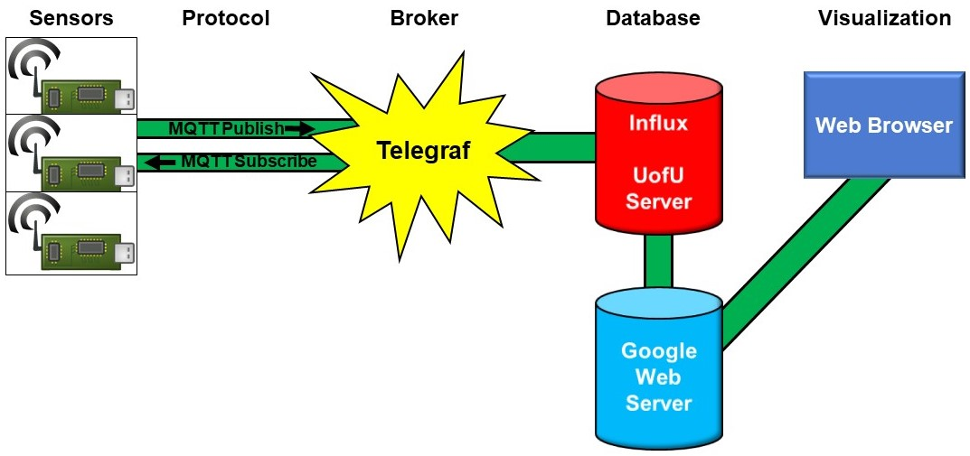

**Motivation:** The current system has several limitations. First, the data is stored on University of Utah servers. These servers are managed by the University and access can be difficult for users not associated with the school (private citizens). Second, the lifespan of the University servers is limited; the school has indicated a desire to move to cloud-based servers soon. Third, access to the Influx DB is cumbersome and requires custom designed software to query the data.

**Project:** Create a new solution for data transmission and storage that is streamlined with cloud-based services to include a simple visualization interface. The goal is for the system to be completely autonomous from the University of Utah (no dependencies) able to be deployed anywhere in the world. The project will be portable for entities that require data privacy such that new “instances” can be created and rapidly deployed with minimal administrative overhead. Additionally, the project will be scalable to allow for up to 1000 sensors.

*Desired System Model*

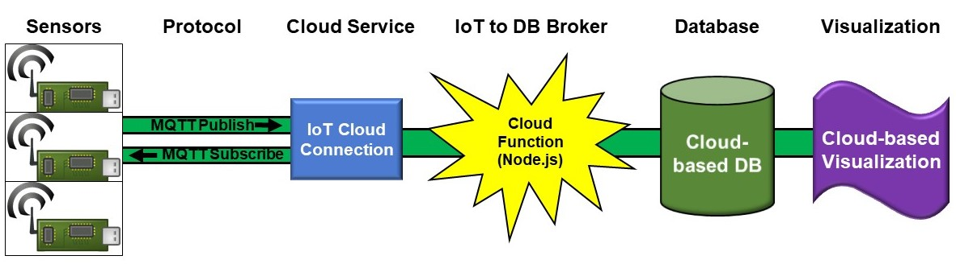

**Objectives:**

1. Connect airU sensors to a cloud-based data center.

2. Store sensor data in a cloud-based database.

3. Create a simple web-based visualization that provides an interactive way to see data.

3a. Control data access through credentials or some sort of authentication procedure.

3b. Develop a web-based mechanism to request a sensor.

4. Portable and scalable solution; possible to create new instances of entire system for interested entities throughout the world.

5. Provide documentation to successfully configure / administer the system.

**Schedule and Milestones:**

Understand and research the current system.

Questions:

1. How does the sensor work (processor, firmware, OS)?

2. How is data sent from the sensor the University of Utah server?

3. How is data stored and accessed?

4. How is data visualized?

End state: Fully understand how the existing system works to inform the design of a new system capable of the same functionality with a more streamlined data pipeline.

Research and design a cloud-based solution.

Questions:

1. What cloud services are available?

2. What cloud services provide IoT connectivity, data storage, data visualization?

3. How do IoT devices connect to cloud-service?

4. How much do cloud services cost to utilize?

End state: Select a specific cloud-based company that can provide all the necessary services for an acceptable fee.

Connect a sensor to the selected cloud service.

Deliverables:

1. Update the sensor firmware to connect to the cloud.

2. Create required cloud infrastructure to accept connection from a sensor.

End state: Sensor successfully connects to a cloud-service.

Create a cloud DB and visualization (user interface) to view data.

Deliverables:

1. Cloud-based DB capable of storing data from 1000 sensors for 3 years.

2. Create a visualization interface that can be shared with users to visualize and analyze collected data.

End state: Senor successfully stores data in a cloud-based DB from which data can be queried and visualized in a portable manner to users.

Testing and dynamic sensor configuration (updates to firmware).

Deliverables:

1. Successful test of many sensors reporting / storing accurate data with ability to visualize data collectively or individually.

2. Configure 10 sensors offsite (away from University) and have them operate continuously for a week.

3. Establish a way to update the firmware of a device utilizing cloud services.

4. Reduce storage requirements by only transmitting / storing data when it changes from previously transmitted / stored data.

End state: Baseline systems works free of error. DB stores data properly. Visualization can uniquely represent data from each sensor.

Authentication and portability.

Deliverables:

1. Incorporate user authentication into the data reports to protect data and make it accessible only to those with the proper credentials. The ideal will be to use something like a Google account username and password to grant access to the data.

2. Streamline a way to clone or create new instances of the entire project so that it can be shared with other organizations. This step will include providing all the documentation to administer / configure the system.

End state: A complete portable cloud-based solution with documentation that can be shared / implemented by another organization (turn-key solution).

Project review and adjustments. This time period will be used to review the project with my advisor and committee and demonstrate the functionality, capabilities, and limitations. I will use feedback from this interaction to adjust, incorporate additional features, and / or redefine project scope to meet the intent and complexity of a graduate level-project.

Finalize project (incorporate feedback) - prepare for presentation.

Project presentation to committee.